OUR STORY

Located in the heart of historic Old Town Manassas adjacent to sister restaurant Carmello’s, Monza is a vibrant, super comfy bistro the whole family will enjoy any night of the week! You'll love our delicious brick oven pizzas, homemade pasta, salads & sandwiches. Not only do we have the best craft beer and wine selection in town, our bar serves up the freshest, most creative cocktails for miles. Join us and stay awhile!

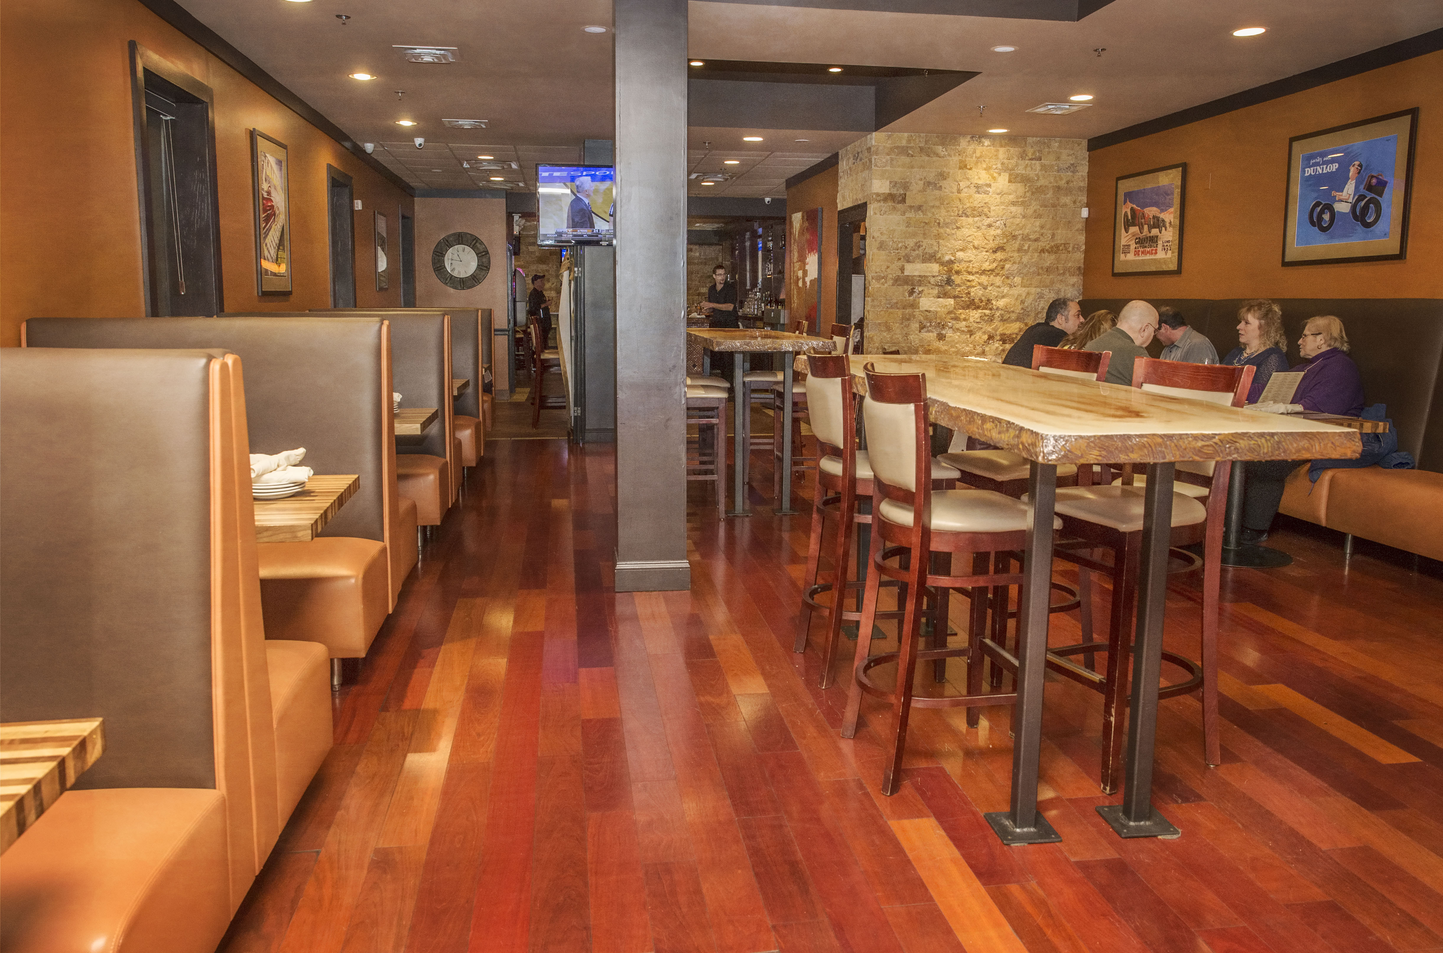
The Autodromo Nazionale Monza racing track is the biggest event in the Formula One Italian racing Grand Prix circuit. It’s been hosted there since the Sports Inception. This is where we get our name Monza.

Appetizers
Arancini
House made mixture of Fontina & Parmesan cheeses, risotto, chives, onions, garlic & bread crumbs with marinara sauce on side 14

Brick Oven Oysters Rockefeller
Fresh Rappahannock oysters baked with spinach, bacon, breadcrumbs, fennel & Parmesan topping 16

Bruschetta
Crostinis topped with marinated diced tomatoes, roasted red pepper & fresh mozzarella crumbles with balsamic reduction 12

Buffalo Chicken Dip
Mixture of cream cheese, shredded chicken, buffalo sauce & ranch, served with house made tortilla chips 16

Calamari Fritti
Lightly battered fresh squid, deep fried & served with marinara sauce 14

Charcuterie & Cheese Platter
Assorted cured meats & cheeses with sides of Dijon, honey &
crostini 19.25

Chicken Tenders (4)
Breaded & deep fried chicken tenderloins 13

Chicken Wings (10) Baked or Fried
Choices: Plain, Buffalo, BBQ, Teriyaki, Sweet & Sour, Chili or Chipotle
Dipping sauces: ranch or bleu cheese or both (.50 for extra sauce) 14.75
(Minimum of 30 minutes for baked wings)

Baked Spinach Artichoke Dip
House made mixture of spinach, artichokes, cream cheese, sour cream, mayo & Parmesan with tortilla chips 16.25

Bacon Wrapped Drunken Shrimp (5)
Bacon wrapped shrimp with drunken sauce drizzle 16

Sesame Crusted Ahi Tuna
Ponzu, wasabi, pickled ginger, sriracha aioli
Half 18.25 Full 32.25

Stuffed Jalapeños
Bacon wrapped and stuffed with cheddar and cream cheese, with chipotle aioli drizzle & Ranch dressing 13

Mozzarella Sticks
Homemade, hand battered & deep fried with Marinara 13.5

Italian Meatballs (3)
House made with veal, pork, beef, onions, peppers, garlic, Italian herbs, bread crumbs, eggs, fresh mozzarella, parmesan & tomato sauce 12.75

Soup of the Day
Cup 7
Bowl 9

Salads
Monza
Mixed baby greens, tomatoes, dried cranberries, red onion, diced cucumber, walnuts & feta with Balsamic Vinaigrette Small 9.50 Large 14
Arugula
Arugula, almonds, shaved Parmesan with Citrus Vinaigrette Small 8.50 Large 13.25
Cobb
Applewood smoked bacon, gorgonzola, avocado, sliced boiled egg, corn, cherry tomato & red onion with Ranch dressing Small 9.50 Large 14
Garden
Baby greens, cherry tomato, chickpeas & shredded carrot with creamy Italian dressing Small 8.25 Large 13
Caesar
Fresh romaine, shaved parmesan, house made Caesar dressing Small 8.25 Large 13
Salad Additions:  Grilled Chicken 8.5 | Shrimp 12
Filet Tips 13 | Salmon 12
Ahi Tuna 14.5

Healthy Choices
Beyond Burger™
Plant based burger with lettuce, tomato, onion & side choice 17.25

Vegan Nuggets (6)
Tempura battered plant based nuggets with side choice & dipping sauce 14.25

Pasta Vegetarian
House made noodles zucchini, yellow squash, carrots, celery & onion with garlic pesto sauce 17.75

Chicken Griglia
Grilled chicken breast topped with diced tomato, olive oil, & Balsamic Vinaigrette with seasonal vegetables 22

Salmon & Vegetables
Fresh oven baked salmon filet with seasonal vegetables 25

Sides
Curly, steak or sweet potato fries 6.25
Bread Basket 5.25 | Cole Slaw 3.25
Broccoli 6.25 | Meatballs (2) 8.50
Bacon Mac & Cheese 10  Mac & Cheese 8 | Seasonal Fruit 7.5  Side Salad (see salads) 6.25

Sandwiches
Side Choice: Curly, steak or sweet potato fries, Jalapeño chips, coleslaw or broccoli
Substitute: Cup of soup, fruit or side salad 4.5

Chipotle Grilled Chicken
Blackened grilled chicken, mozzarella, jalapeños, lettuce,
red onion, tomato & Chipotle sauce on Ciabatta 18.25

Southern Fried Chicken BLT
Fried chicken breast, bacon, mozzarella, lettuce, tomato, red onion & ranch on Ciabatta 18.25

Big Pig
BBQ roasted pulled pork, pineapple, cilantro, coleslaw & jalapeños on a brioche bun 18.25

Club Sandwich
Ham, bacon, cheddar, tomato, red onion, mayo & mustard on Texas toast 18.25

Steak & Cheese
Shaved ribeye, mozzarella, lettuce, tomato, banana peppers on a sub roll 18.75
Add bell peppers & onions 2
Add Mushrooms 2

Smoked Salmon Croissant
Smoked Salmon, brie, bacon, capers, lettuce, tomato, red onion on an all butter Croissant 18.25

Godfather Sub
Meatballs, Mozzarella, Zesty Marinara, Sub Roll 18.75

$2 Off Sandwiches & Pasta
11:30 AM – 2:30 PM Monday–Friday
DOES NOT INCLUDE: Sliders, Burgers and Seafood

Build Your Own Burger
Choose: ½ lb. beef patty, turkey patty or
fresh Portobello mushroom starting at 13.5
Side Choice:
Curly, steak or sweet potato fries Jalapeño chips, coleslaw or broccoli
Substitute: Cup of soup, fruit or side salad 4.5

Additions:
BBQ Sauce .50 | Avocado 2.5
Sautéed Onions 1.75 | Mushrooms 2
Bacon 2.5 | Blackened Seasoning 1.25
Banana Pepper 1.75 | Whiskey Glaze 2.5
Cheddar, Swiss, Mozzarella, or Gorgonzola 2

Munchkins Menu
Mini Cheeseburger/Fries 9.75
Chicken Tenders/Fries (2) 9.75
Cheese Flatbread 12
Pepperoni & Cheese Flatbread 13
Mac & Cheese 10
Spaghetti & Meatballs 10

Entrées
Salmon Almondini
Pan seared salmon, roasted almonds with white wine lemon butter sauce & green beans. Choose from tomato rice or capellini with garlic olive oil 25
Chicken Marsala
Grilled boneless chicken breast with mushrooms & Marsala demiglace, served with spaghetti with tomato sauce & broccoli 22
Chicken Picatta
Grilled boneless chicken breast, with white wine lemon butter sauce & capers, served with spaghetti with tomato sauce & broccoli 22
Slow Braised Grilled St. Louis Ribs
1/2 or whole rack of ribs, served with bacon mac & cheese & coleslaw Half Rack 18.5 Full Rack 30

Monza Pot Roast
Marinated & slow cooked roast with carrots & potatoes in savory juices 24

Frango de Churrasco
Marinated & oven roasted half chicken with spicy olive oil, served with broccoli & choice of tomato rice or steak fries 22
NY Strip alla Funghi
10oz NY strip, grilled and topped with Shitake mushrooms sautéed in garlic butter, served with steak fries & broccoli 29
Chicken Parmesan
Lightly Breaded Chicken Breast, Mozzarella, Spaghetti, Tomato Sauce 22

Sliders
Side Choice: Curly, steak or sweet potato fries, Jalapeño chips, coleslaw or broccoli
Substitute: Cup of soup, fruit or side salad 4.5
Beef Sliders (3)
All beef patties with bacon, cheese, lettuce, tomato, onion, ketchup & mayo 18.75

Hula Pig Sliders (3)
BBQ pulled pork, coleslaw, cilantro, pineapple & jalapeños 18.75

Pasta
Jack’s Special
Shrimp, scallops & crab meat with capellini tossed in a creamy white wine lemon butter sauce 32

Bucatini Diablo
Grilled chicken, spicy Italian sausage, sauteed red & green peppers tossed with Bucatini pasta & Cajun cream sauce 22

Scampi Ligure Or Marinara
Sautéed shrimp & linguini, with choice of garlic lemon butter or marinara sauce 26

Tortellini Crema Rosa
Cheese tortellini with chicken & mushrooms, tossed in crema rosa sauce 21

Capellini With Meatballs
House made meatballs with capellini tossed with tomato & garlic olive oil sauce 21

Fettuccine Alfredo
Fettucine tossed in Alfredo sauce 13.50
With chicken 8
With shrimp 12

Spaghetti Carbonara
Spaghetti with sautéed onions, bacon, Pecorino Romano & Parmesan cheeses in a cream sauce 21

Lasagna Bolognese
Pasta sheets layered with Ricotta, beef, sausage & veal, baked in house made tomato sauce 21
Beef Ragu
Short ribs, carrots, fennel, onions in demi glace over pappardelle 25

Pizza & Flatbread

All pizzas & flatbread served with Parmesan & red pepper flakes on side
Monza
Italian sausage, pepperoni, chicken & mozzarella with marinara sauce base
Flatbread 14.25 | Pizza 12” - 16.25, 16” - 21.75

Queen Margarita
Fresh mozzarella, fresh tomato with tomato sauce base, topped with fresh basil
Flatbread 14.25 | Pizza 12” - 15.75, 16” - 20.75

New York White Pizza
Mozzarella, parmesan, garlic olive oil & herbs
Flatbread 13.5 | Pizza 12” - 15.25, 16” - 20.75

Arugula
Fresh mozzarella, prosciutto, arugula & balsamic reduction drizzle
Flatbread 14.75 | Pizza 12”- 16.75, 16” - 21.75

Hawaiian Pulled Pork
Pulled pork, bacon, cilantro, jalapeños, pineapple & mozzarella with BBQ sauce
Flatbread 14.75 | Pizza 12” - 16.75, 16” - 21.75

Buffalo Chicken
Shredded chicken, gorgonzola, mozzarella & red onion with buffalo sauce
Flatbread 14.25 | Pizza 12” - 16.25, 16” - 21.75

Meathead
Sliced meatballs, bacon, prosciutto, pepperoni, Italian sausage & mozzarella with a marinara sauce base
Flatbread 15.75 | Pizza 12” - 18.25, 16” - 23

25% off all pizzas & flatbreads
10PM-12AM ~ Friday & Saturday
Bar Area Only

Brunch
10:30 AM - 2:30 PM
Saturday & Sunday

French Toast
2 slices french toast with bacon & 2 eggs any style 9.5

Belgian Waffles
2 Belgian waffles with whipped cream & fresh fruit topping 13

Chicken & Waffles
Buttermilk fried chicken breast atop a Belgian waffle 18

Eggs Benedict
Two poached eggs on an English muffin with Hollandaise sauce & home fries with red & green bell pepper & onion 16
Add Protein 23
-Smoked Virginia Ham
-Filet Mignon
-Smoked Salmon

Biscuits & Gravy
3 biscuits with sausage gravy 11.50
Add Cheddar & Bacon 2

Country Fried Steak
Breaded deep fried steak with sausage gravy & home fries with red & green bell pepper & onion 15.5

Steak & Eggs
4oz petit Filet Mignon, 2 eggs any style & sweet potato fries 22

Bacon, Egg, & Cheese English Muffin
With home fries with red & green bell pepper & onion 13.50

Create Your Own Omelette
8.5
Additions:
Bacon 2.5
Sausage 2.5 | Shrimp 7
Ham 2.5 | Avocado 2.5
Mushrooms 1.75 | Onions 1.75
Peppers 1.75 | Tomatoes 1.75
Spinach 1.75 | Fresh Mozzarella 2.25
Cheddar, Swiss, or Mozzarella 2

Brunch Sides
1 egg any style 2.5
2 biscuits with sausage gravy 8
Cup of sausage gravy 6
3 Pieces of Bacon 5
3 Pieces of Sausage 5
2 Pieces of Toast 4
Home Fries 5
Seasonal Fruit 7

Brunch Cocktails
Bacon Wrapped Bloody Mary
Murlarkey Salsa Borracha Whiskey, house bloody mary mix, lime, celery, bacon wrapped shrimp 14.5

Elderflower Bellini
St. Germain elderflower liqueur, sparkling white wine, pineapple juice 10.5

Battle Street Spritz
21 Seeds Valencia Orange Tequila, Aperol, prosecco, splash club, orange slice 10 .5

Zero Proof Cocktails

Ginger Shandy
Ginger beer, lemonade, lemon twist 5

Glass Half Empty
Pineapple juice, grapefruit juice, lime juice, Angostura bitters, seltzer 6.25

Sparkling Cherry Limeade
Grenadine, lime juice, club soda 4.25

Summer In November
Ginger beer, seltzer, muddled mint, fresh lime juice, blackberry vanilla bean syrup 6.25

Wine by the Glass
$1.5 Off House Wine glasses during Happy Hour

Red

House Pinot Noir 9.5

House Merlot 9.5

House Cabernet Sauvignon 9.5

House Portuguese Red 9.5

San Vito Chianti 12

Finca Malbec, Argentina 11.5

Elouan Pinot Noir, CA 12.5

Quinta De Chocapalha, Portugal 11.5

J Lohr Cabernet Sauvignon, CA 12.5

Seven Falls Merlot, WA 11.5

White

House Chardonnay 9.5

House Pinot Grigio 9.5

House Sauvignon Blanc 9.5

House Moscato 9.5

House Riesling 9.5

House Portuguese White 9

House White Zinfandel 9

Monte Velho, Portugal 11

Antonio Facchin Prosecco, Italy 9.5

Rosé

House Rosé 9.5

Sangria
Made With Fresh Fruit
Available by the Glass or Pitcher

Blackberry Sangria
Muddled blackberries, blackberry liqueur, apricot brandy, Moscato, club soda
Glass 12 Pitcher 45

Strawberry Basil Mint Sangria
Muddled strawberry & mint & basil, Smirnoff Strawberry, strawberry liqueur, moscato, club soda
Glass 12 Pitcher 45

Red, Rosé, or White Sangria
Glass 12 Pitcher 45

Port Cocktails

Bar Drake Manhattan
Tincup Whiskey, ruby port, maple syrup & bitters 13.5

DayTripper’s Bramble
Hendrick’s gin, fresh lemon juice, pure cane sugar & ruby port 11.5

Port Sour
Crown Royal Vanilla Whiskey, lemon juice, pure cane sugar, egg white topped with Ferreira ruby port 11.5

Bottle Beer & Draft Beer List Available Upon Request

Draft Beer Menu Updated Daily On Untappd
Ask your server or see our Untappd List on TVs

Red Wine by the Bottle

#NB San Vito Chianti 42

#229 Di Majo Sangiovese 38

#337 Quinta Do Encontro Tinto. 38

#341 Quinta Da Pacheca Superior 38

#344 Quinta De Chocapalha 40

#515 Elouan Pinot Noir 45

#NB Seven Falls Merlot 39

#NB Lar de Paula Temprañillo 39

White Wine by the Bottle

#122 Quinta de Soalheiro Alvarinho 48

#120 Esporão Monte Velho 38

#NB Spy Valley Sauvignon Blanc. 42

#NB Two Mountain Riesling 35

Flights
Jameson Flight 25
(IPA, Cold Brew, Black Barrel)
The Glenfiddich Flight 32
(12 Year Malt, 14 Year Bourbon Barrel Aged, 18 Year)
The Glenlivet Flight 32
(Caribbean Cask, 12 Year Single Malt, 15 Year French Oak Reserve)
Hennessey Flight 32
(Hennessey XO, Hennessey VSOP, Hennessey VS)
Taste of Luxury Flight 47
(Don Julio 1942, Hennessy XO, Glenmorangie Signet)

Martini List
All House Martinis $6.5 Every Monday

Battle Bee
KO Battle Standard Gin, fresh lemon juice, Grade A Honey, lemon twist 11.5

Blood Orange
Three Olives Orange Vodka, Solerno Blood Orange liqueur, orange & cranberry juices 11.5

Blackberry Sidecar
Ketel One Vodka, triple sec, fresh lemon juice, muddled blackberries with a sugar rim 11.5

Double Espresso
Smirnoff Whipped Vodka, Bailey’s Irish cream & fresh shot of espresso 11.5

Green Appletini
Smirnoff Green Apple Vodka, sour apple liqueur, splash sour mix 11.5

Peach Fuzz
Ketel One Peach & Orange Botanical Vodka, cranberry juice, orange juice 11.5

Strawberry Henny
Hennessy VS, triple sec, strawberry syrup, splash ginger ale 11.5

Watermelon Breeze
Smirnoff Watermelon Vodka, watermelon liqueur, St. Germaine Elderflower liqueur, muddled cucumber, cranberry 11.5
Craft Cocktails

Very Special Old Fashioned
Hennessy V.S.O.P Privilege, pure cane sugar, Angostura bitters, muddled orange & cherry 13.5

Captains Punch
Captain Morgan Original Spiced Rum, apricot brandy, lime, ginger ale, cherry floater, cherry garnish 10.5

Smokey Mountain Paloma
Union Mezcal, lime juice, pure cane sugar, grapefruit juice, club soda 10.5

Monza Lemonade
Three Olives Vodka, Campari, lemonade, pure cane sugar, splash club, lemon 12.5

Pineapple Smash
Tincup Whiskey, Angostura bitters, pure cane sugar, muddled pineapple, lemon & mint 11.5

Electric Margarita
1800 Blanco Tequila, blue curacao, pure cane sugar, fresh sour, lemon and lime, pineapple floater 10.5

Cucumber Cooler
Ketel One Cucumber & Mint Botanical Vodka, St. Germaine liqueuer, fresh lime juice, cane sugar, muddled cucumber, topped with prosecco 10.5

1800 Mule Refresher
1800 Cucumber Jalapeno Tequila, fresh lime, ginger beer, mint sprig 11.5

